Tracing the Growth of the Global Community

A Population Forecasting Analysis The world’s population is more than three times larger than it was in the mid-twentieth century. The global human population reached 8.0 billion in mid-November 2022 from an estimated 2.5 billion people in 1950, adding 1 billion people since 2010 and 2 billion since 1998. The world’s population is expected to increase by nearly 2 billion persons in the next 30 years, from the current 8 billion to 9.7 billion in 2050 and could peak at nearly 10.4 billion in the mid-2080s. This dramatic growth has been driven largely by increasing numbers of people surviving to reproductive age, the gradual increase in human lifespan, increasing urbanization, and accelerating migration. Major changes in fertility rate have accompanied this growth. These trends will have far-reaching implications for generations to come.

PURPOSE

IT IS USE FULLY FOR PROJECT DEVELOPMENT AND WORK IN COMPANY SECTOR.

WE ARE DEVELOPED SKILLS USING WITH THE PROJECT

EMPATHY MAP

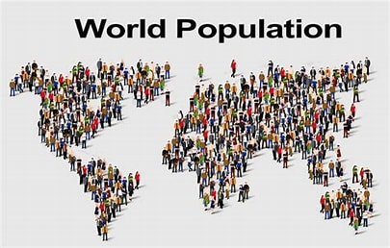

BRAINSTORMING MAP

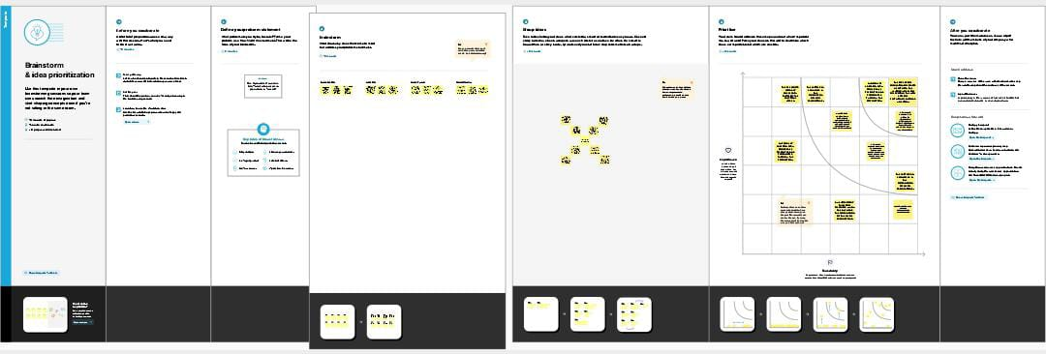

RESULT

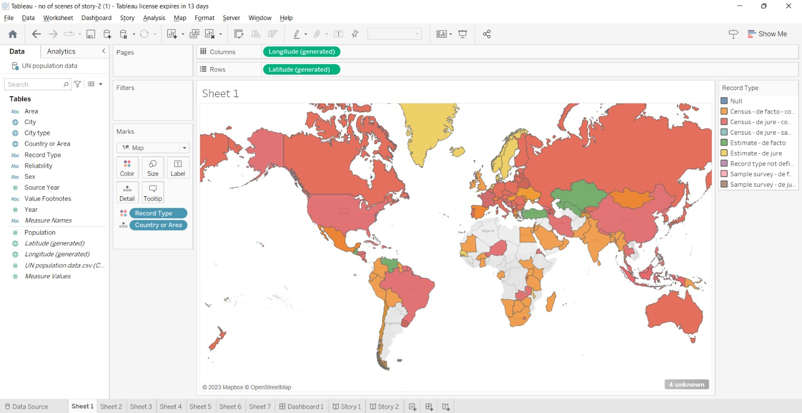

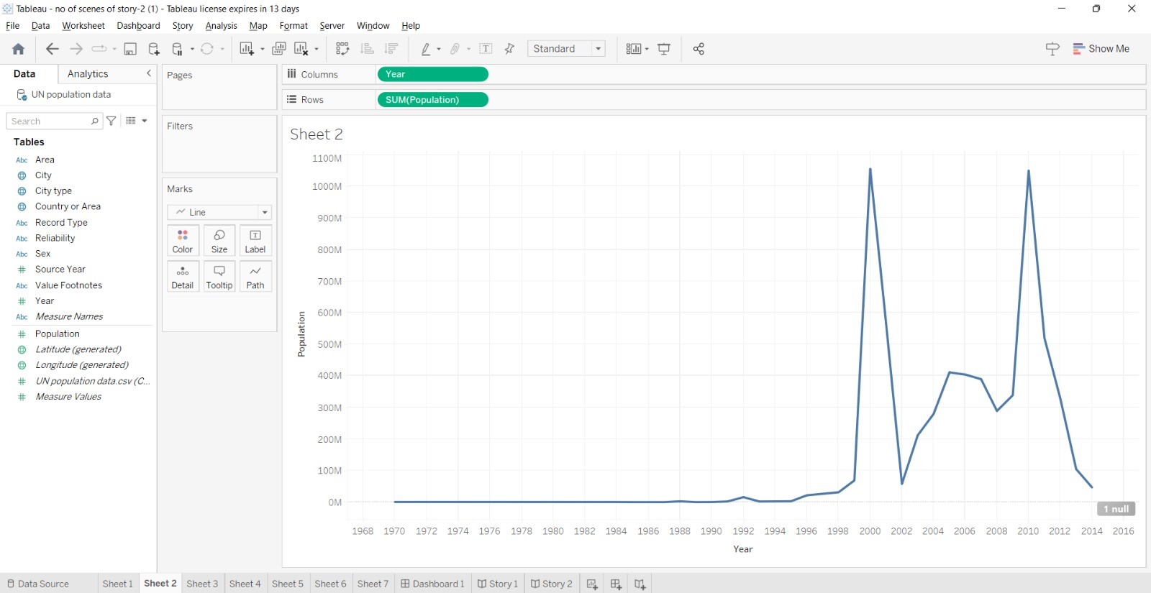

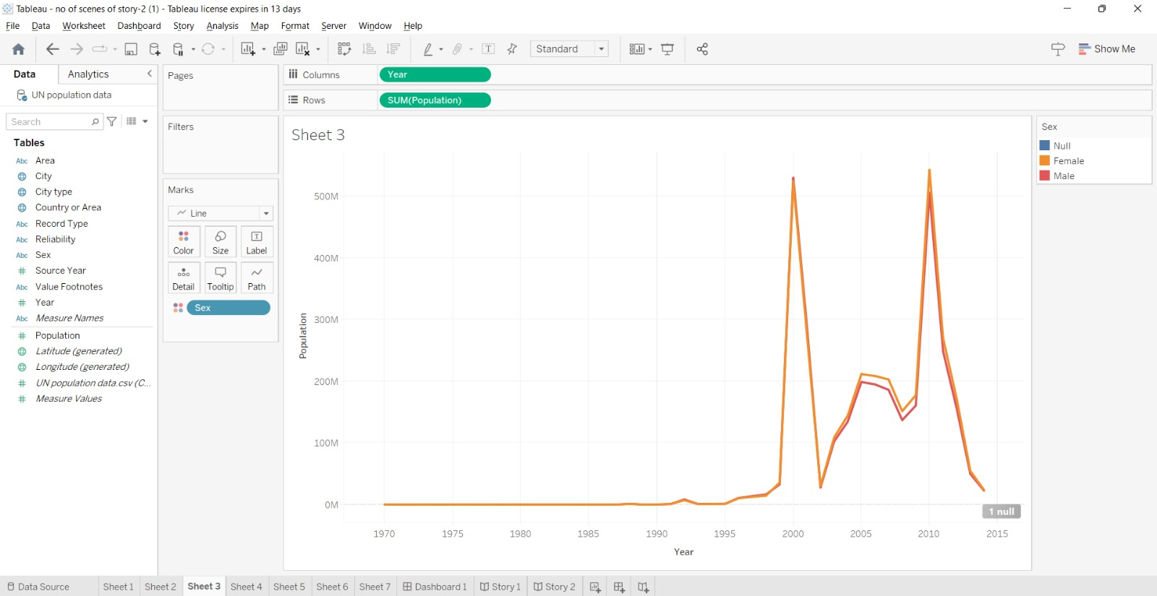

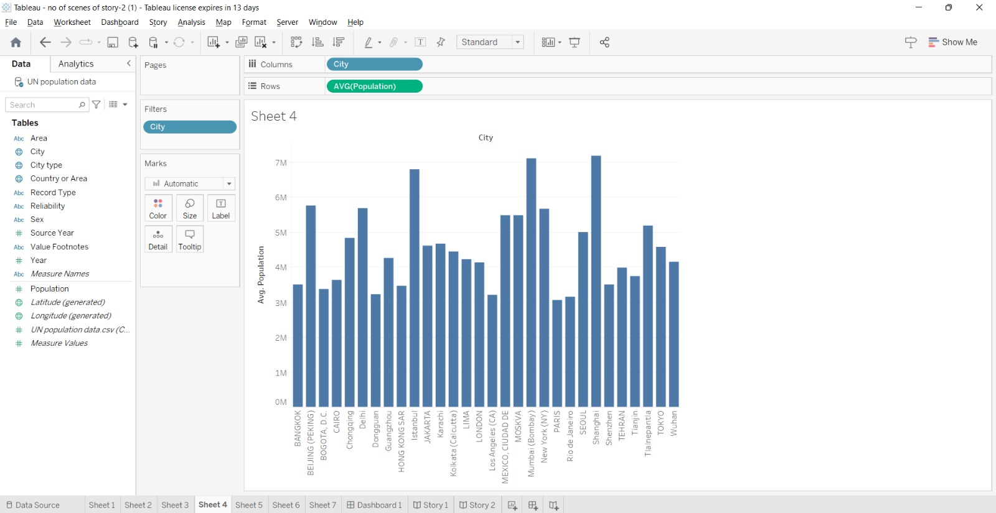



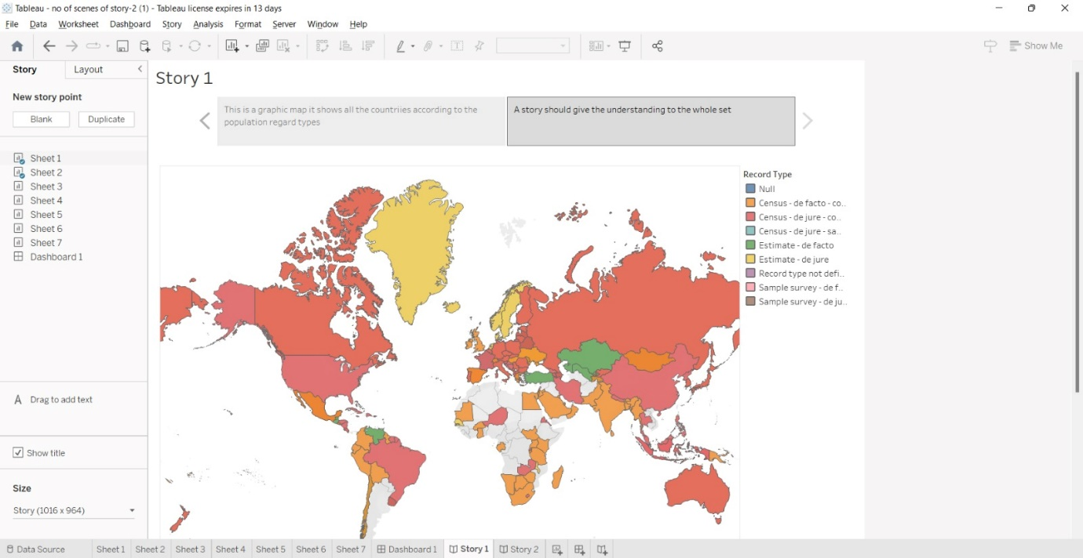

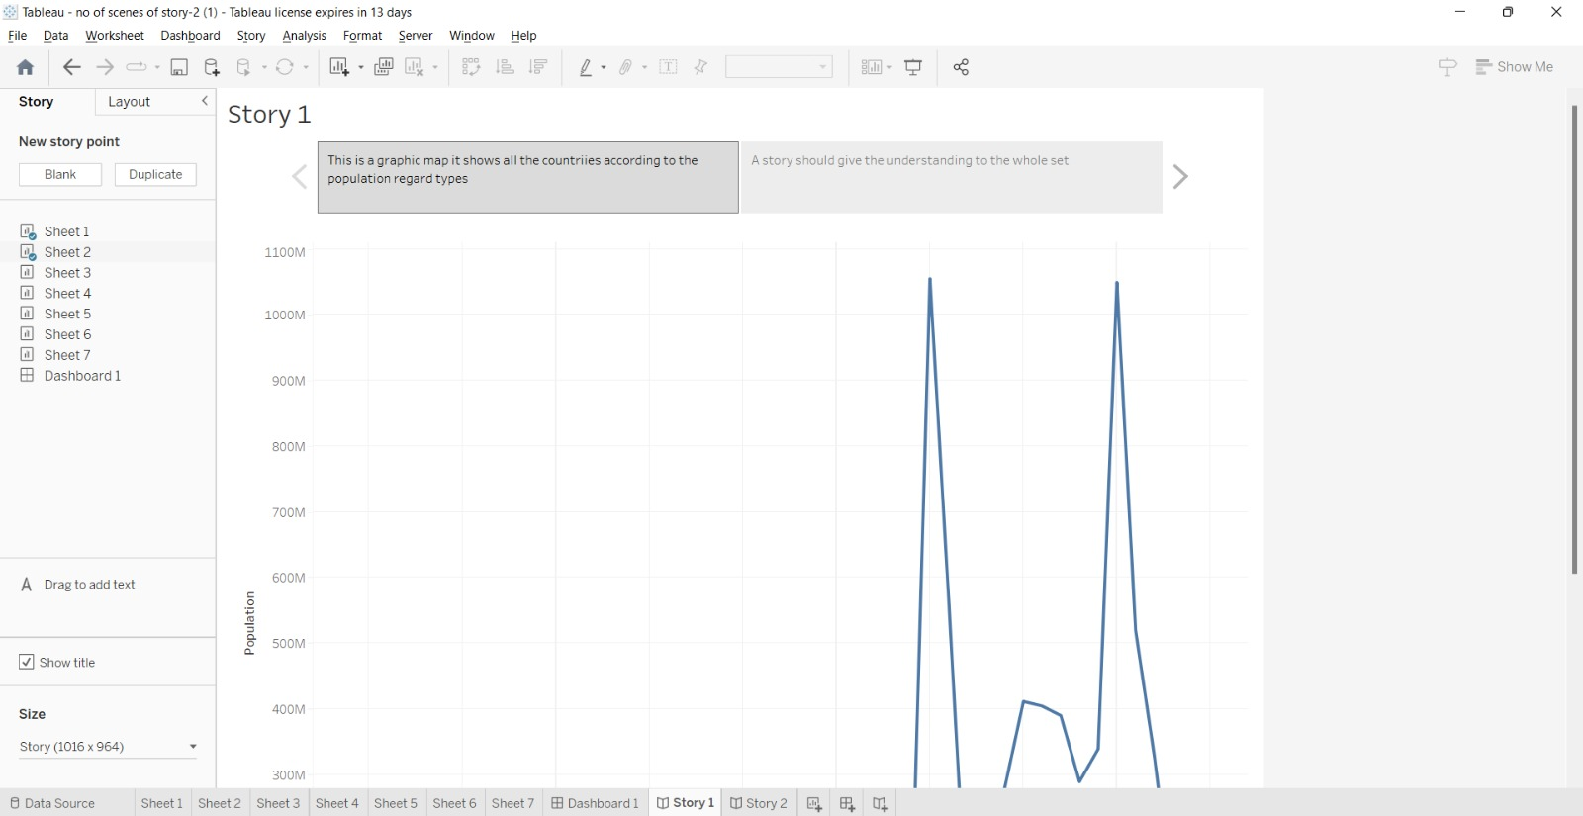

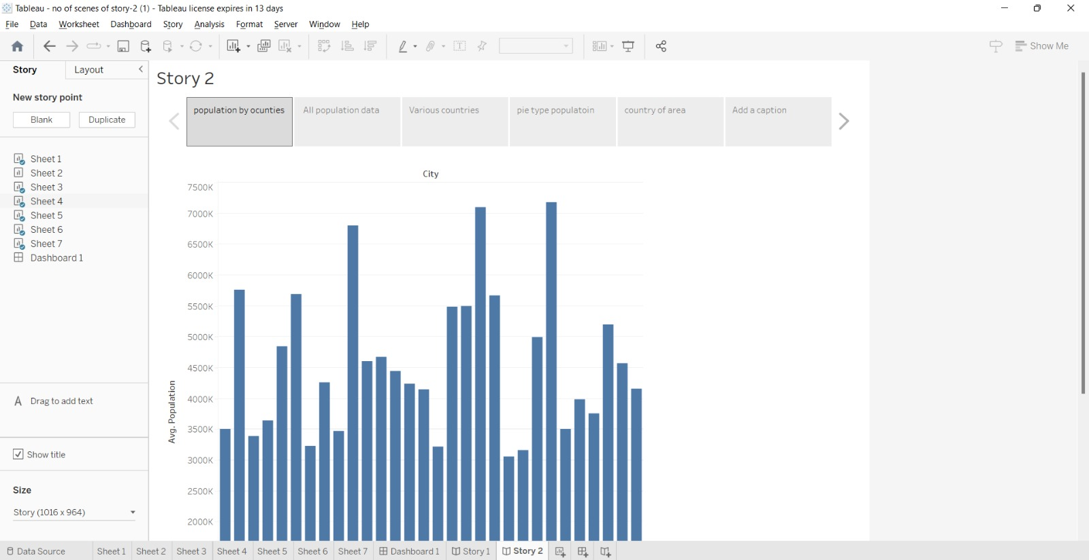



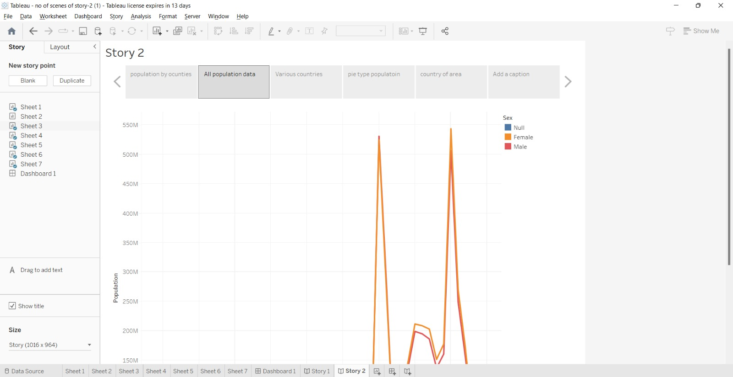

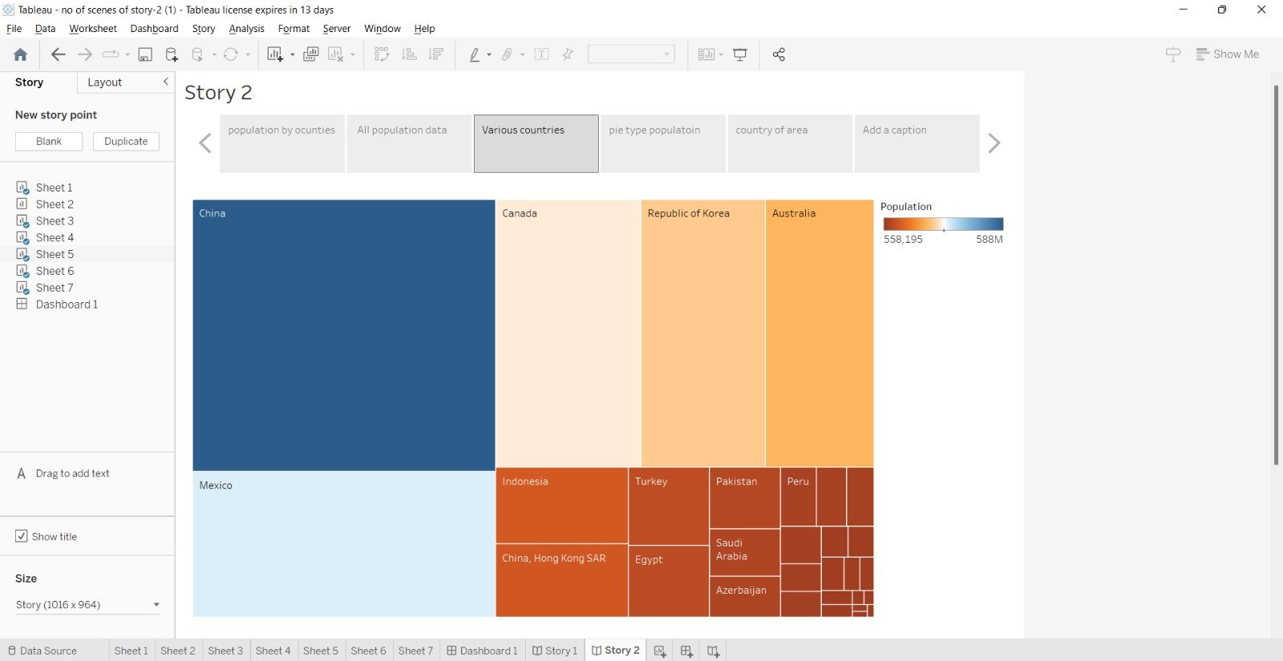

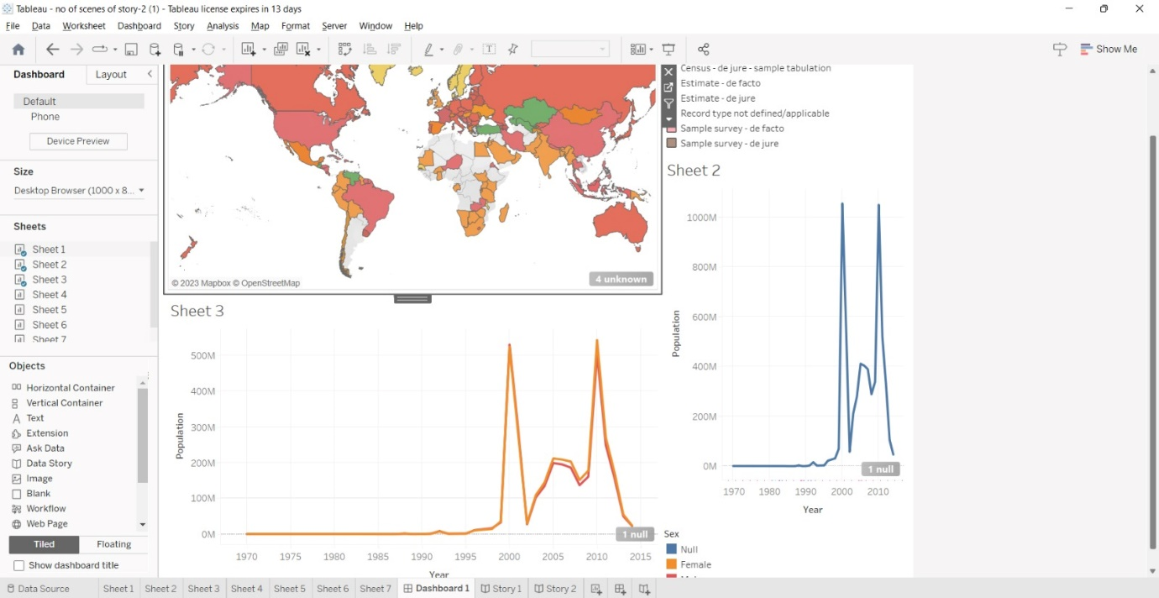

POPULATION ADVANTAGES &DISADVANTAGES

ADVANTAGES

* **Greater economic growth**

Population growth will lead to economic expansion since more people can produce more goods. More money will be available in tax revenue to fund public services like environmental and health care programs. The obvious conclusion is that GDP per capita is the essential element rather than GDP as a whole.

* **Human Resources will Increase.**

One obvious advantage that a large population might offer is a larger supply of human resources. In locations where unemployment is a serious problem, this will likely not lead to more jobs, but it will boost the number of individuals willing to work for less pay.

* **Increased productivity through specialization**

The demand for products and services will rise as the population grows, encouraging specialization. This indicates that some people concentrate on creating a single product or service. However, each person's efforts may merge into something amazing depending on their distinct abilities and talents.

Additionally, specialization enables countries to export and participate in globalization. Producers can export commodities to areas afflicted by natural catastrophes or artificial risks instead of only producing locally.

* **Demand has led to more jobs.**

More people means a greater demand for products and services, so more jobs are needed for production. Workers are needed at every level, from the production of basic materials through multiple stages to final distribution during consumption.

More employees are necessary throughout this procedure; thus, they can be needed today even if they weren't previously required for certain talents. Several countries are investing in regulating declining birth rates to address the impending labor deficit.

* **Rapid population decreases Social Infrastructure**

The government must spend a lot of money on necessities like housing, healthcare, and education. However, a rapidly growing population makes the load heavier.

* **Higher population density efficiency**

High population density locations are much more efficient than rural areas and regions with low populations in terms of the per capita carbon footprint. People are more likely to use public transportation and live in easier-to-heat apartment complexes when they reside in densely populated locations.

* **Diversity fosters creativity**

Studies that examined the benefits of immigration as a crucial source of innovation have demonstrated increased diversity. Adding new cultures to the mix enables people from all backgrounds to approach problems creatively.

* **Improved societal demographic structure**

The population is declining in many western economies, which has led to a skewing of the population toward the elderly and retired. We are struggling to pay for health care & pensions, which is placing costs on society. Moderate population increase contributes to rebalancing the population by increasing the proportion of young, working adults.

* **Higher Industry Demand**

There will be greater demand for some industries in a nation with a higher population. As long as it can produce enough of an item or service to satisfy demand, a company that sells it will experience great success.

* **Increasing military power**

If a country can administer its huge population, it can have a significant military advantage compared to smaller ones. The size of the military will increase, as will the number of military supplies if the economy remains stable and the government can successfully handle the nation's expanding population.

Additionally, a population increase may stimulate technological advancement that would enable the production of more sophisticated military products.

DISADVANTAGES

* **Increasing Resources Demand**

Demand for resources rises as the population grows. Resources, however, are in infinite quantity; thus, this is an issue because if a large number of people utilize them, they'll run out and become scarce, resulting in poverty.

Natural resources will be depleted more quickly due to increased non-renewable resource usage brought on by an increase in population.

* **Shortage of food due to population expansion**

More people means more people to feed, which strains food availability. As a result, food shortages are common in developing countries with quickly growing populations. They cannot feed their expanding population despite their efforts to raise agricultural output.

There are two effects on the growth of the economy from food scarcity. First, a lack of food results in undernutrition, which lowers productivity. It further reduces the workers' capacity to produce. Second, food scarcity requires countries to buy grains, which unnecessarily depletes their foreign exchange reserves.

* **Generating Non-biodegradable waste**.

We are now battling to process the non-biodegradable waste that we are producing. It usually ends up in a landfill, contributing to harmful issues like methane emissions.

* **Increase Pollution**

More people will produce more air, water, and land pollution. Numerous health problems, including asthma and cancer, are linked to higher pollution levels. The pollutants also harm animals and vegetation.

* **Threat to Natural Habitat**

As there is a growing need for houses and farming due to an increasing population, there will be a greater threat to natural ecosystems. As a result, there will be more pressure to clear forests to make room for agriculture and habitation.

* **Disturbance in Emergency Situation**

Cities with a high population density frequently have traffic problems. One of the drawbacks of the population is that locations with heavy traffic might be hard to access for emergency vehicles like fire engines and ambulances.

Emergency services are required when there is an accident or another natural disaster.

* **Infections Outbreaks**

The World Health Organization (WHO) asserts that areas with high population densities may see fewer disease outbreaks and lower infection rates. It is much simpler for germs and viruses to move from person to person when so many people live close to one another.

The Covid-19 pandemic provides a clearer explanation for why cities with large densities of people saw greater incidences of viral infection-related fatalities.

* **Effect on climate**

The consequences of climate change will also be seen because of rising greenhouse gas emissions, a major cause of global warming. As the population continues to increase, more damage is being done to our ecosystem.

The ecosystem is under stress due to human consumption and population density, which has reduced biodiversity and increased greenhouse gas emissions from processes like dairy production.

* **Water Shortage**

The pressure that a growing population will place on limited water resources contributes to many small and large wars as nations struggle to solve the water crisis.

* **Capital production declines as the population grow**

To boost capital production, developing countries manage the population composition. Due to the high birth rate & short life expectancy, these countries have comparatively high dependency rates. Rapid population growth in emerging countries reduces the quantity of capital accessible per person, which lowers the workforce's productivity. As a result, their income decreases, and they are less able to save money, negatively affecting capital formation.

* **A large population exacerbates unemployment.**

A fast-expanding population means that a sizable number of individuals will join the labor force, many of whom may be unable to find employment. The number of job seekers is increasing so quickly in developing countries that it will be difficult to employ everyone despite all attempts to promote planned growth. These countries frequently experience underemployment, unemployment, and covert employment. The rapid increase in the global population makes it practically impossible for economically developing nations to address their unemployment issues.

* **Low Quality of Life**

Most Indians have a poor quality of life due to the country's rapidly expanding population. According to Human Development Report, low quality of life is demonstrated by a lack of knowledge due to illiteracy, a lack of economic security due to the number of people without access to health care and clean water, and a high proportion of children under the age of five who are severely underweight.

APPLICATIONS

The spatial aggregation of addresses open data to produce population distribution maps with a fine spatial resolution resulted in reliable grids, created in a simple and fast way, which is a major contribution towards cost-saving, time-saving, and scientific sound. The proposed methodology makes it possible to produce up-to-date and reliable population estimates, between censuses, if there are new data on addresses and the auxiliary variable relative to the weight of the population/population density is coherent in time and space. In contexts of urban expansion and/or urban regeneration with significant changes in urban planning parameters, the methodology can be applied if the weights of population density can be obtained from other proxy variables, namely the indexes of master plans.

Although the results prove to be promising, there are challenges and future improvements to consider regarding data and spatial granularity. Further work needs to carry out to increase the resolution of the grids to 100, 50 m or less and on the use of auxiliary information regarding the addresses and the number of housing units based on LíDAR surveys through mobile mapping or collection of georeferenced (360°) panoramic images.

CONCLUSIONS

The population is a complicated subject with benefits and drawbacks. Even though population density might be a sign of economic expansion, it has other negative environmental effects, including a lack of fresh water. It might boost economies and industries while also encouraging greater innovation. Additionally, it can put food, property, and other limited resources like water at risk.

The advantages and disadvantages of how big or small the population should be for a country are fully explained in this article.

FUTURE SCOPE

High population density locations are much more efficient than rural areas and regions with low populations in terms of the per capita carbon footprint. People are more likely to use public transportation and live in easier-to-heat apartment complexes when they reside in densely populated locations.

* **Diversity fosters creativity**

Studies that examined the benefits of immigration as a crucial source of innovation have demonstrated increased diversity. Adding new cultures to the mix enables people from all backgrounds to approach problems creatively.

* **Improved societal demographic structure**

The population is declining in many western economies, which has led to a skewing of the population toward the elderly and retired. We are struggling to pay for health care & pensions, which is placing costs on society. Moderate population increase contributes to rebalancing the population by increasing the proportion of young, working adults

APPENDIXss

https://drive.google.com/file/d/1ENkCz720zYhmor88ETNEh_HW7H2EbTYc/view?usp=drivesdk